COVID-19 GUIDELINES-AS OF JULY 4 2021.

COVID-19 – EXHIBITOR GUIDELINES
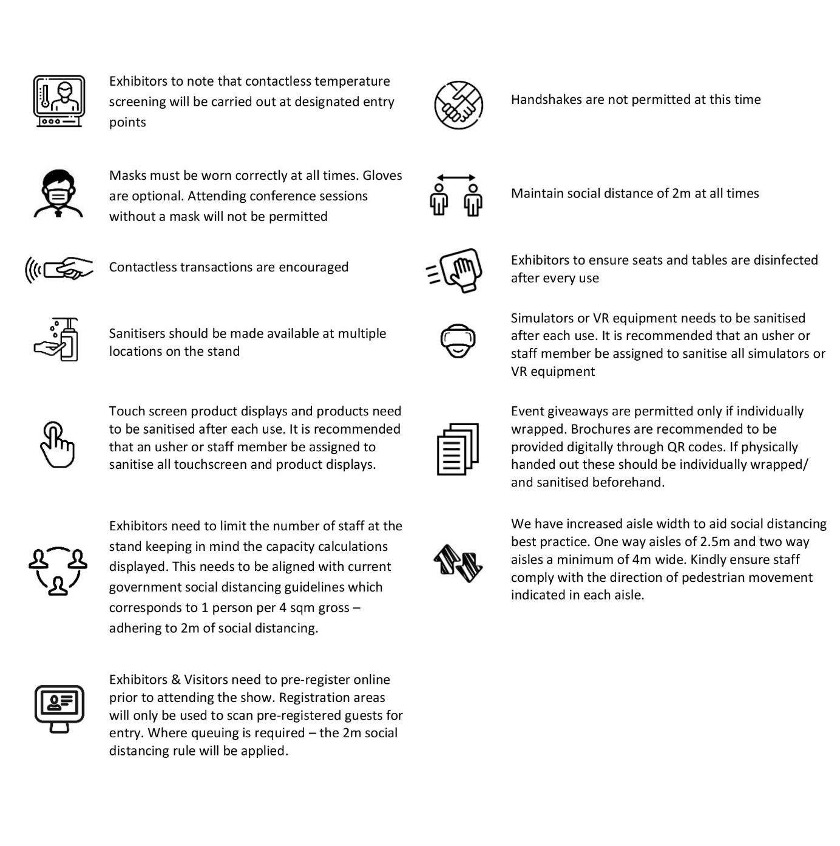

COVID-19 - STAND BUILD GUIDELINES
Dubai World Trade Centre (DWTC) has put together a framework of guidelines and best practices which strictly adhere to all rules and regulations laid out by government authorities including Dubai Health Authority and Dubai Municipality to ensure the health and safety of everyone on our premises. This includes both measures for headcount and space management, hygienic, technical and organisational measures for running exhibitions, congresses and trade fairs. The hygiene and infection protection standards are constantly monitored and will be updated according to government authority updates and changing legal requirements. For the time being, the following shall be observed:
Simplified/Modular Stands
With build up time limits in place, stand designs should be simplified and be pre-fabricated or modular in construction to facilitate efficient assembling. This will ensure less manpower onsite. Your stands must be completed by 10pm on the last night of the build up phase. No late night or overnight work will be permitted as the remaining time is required for deep cleaning, sanitisation and fumigation of halls, before opening.

Review of Stand Design
Key considerations for stand designs:
- The minimum stand size needs to be 3m x 3m.
- The material used for surfaces of walls, counters, floors and furniture needs to be easily cleanable.
- After taking into account product displays, models, walls and furniture etc. the stand design should ensure that a minimum 80% of the total space is open space. If there is a requirement that will impact this, then the number of people allowed on the stand need to be adjusted.
- For stands that have a depth of 6m or more, it is highly recommended to have reception counters, furniture, product displays and models set back by a minimum of 1m to discourage queueing in aisles and to ensure social distancing.
- Where exhibition stands have interactive displays and/or product demonstrations that involve visitors touching and using items, the exhibitor should ensure social distancing measures are in place, and that all items are wiped/sanitised between each interaction.
- It is strongly recommended to have clear screens/shields on all reception counters. If this is not possible we recommend the receptionist or host/hostess wears a face shield in addition to a face mask. The number of staff at these counters should be limited to only one person at any time. Hand sanitisers should be available at all reception counters at all times.
- In areas on the stand that are being utilized for one on one meetings which involves interaction between many visitors, it is recommended to have protective screens in place.
- Exhibition stand giveaways are allowed only if distributed by a member of staff/usher or hostess who is wearing disposable gloves. Brochures are recommended to be provided digitally through QR codes.
Double-Decker stands (if applicable)
- If a staircase is under 4m in width then it must have an access control at the top and bottom to ensure that only one person is using them at a time. This control can be as simple as a rope and post with an usher or staff member controlling access.
- For stands with a staircase more than 4m wide, a centre handrail needs to be in place, with floor signage on the stairs to clarify direction of movement.
- Larger stands may consider adding a second staircase: one for going to the upper deck and one for going down to the ground floor.
Stand Capacity
- The maximum number of people permitted on a stand should correspond to 1 person per 4sqm. Therefore, the capacity of people (exhibitors and visitors) = Total Stand Space ÷ 4
- The maximum number of people allowed at the stand at any time should be displayed on the front of the stand via a signage board or a sticker. The size of this sign or sticker needs to be a minimum of 50cms x 30cms.
- It is recommended that all stands have floor stickers to highlight social distancing within their stands.
Boardroom/Meeting Space on Stand
- Boardroom space on the stand needs to be large enough to incorporate social distancing regulations. The capacity guideline (1 person per 4sqm gross or minimum of 1.5m between chairs) should be used to determine the number of people permitted within the space.
- Air circulation in enclosed areas should be considered.
- Physical barriers can be used as an alternative to social distancing
- Physical barriers must be higher than the head of the person when seated and cover the full torso
- Temporary barriers should be made of suitable material such as plexiglass (acrylic).The barrier should not be perforated and must have a plain surface that is easy to clean and disinfect.
Preventative Measures
- Sanitisation needs to be conducted at the end of every exhibition day by the exhibitor. Frequent sanitization of exhibition stands, furniture, product display/refrigerator units, stages, equipment (sports, musical, electronic, etc.), F&B areas/equipment
- Sanitisers need to be made available on all stands for both staff and visitors. Gloves can additionally be made available.
- Only touchless water dispensers are permitted. Sealed bottled water will also be allowed on stands –these are available for purchase from EventPlus.
- Storage behind perimeter stands is not permitted, any items (including stand material) found behind stands will be removed during the daily master cleaning.
Stand Material Drop-off
- Contractors are reminded to prepare the stand material several days in advance and deep clean/sanitise the material before it is loaded onto vehicles.
- All BOH and FOH deliveries must go through thorough sanitisation and full checks and must be certified as being checked by the contractors by submitting to the organiser an undertaking letter on arrival the venue
Contractors on Stands During Build-up
- Teams on the stand should not exceed the maximum number defined by the social distancing norms. It is accepted that at times this will be a challenge as normal health and safety practices still need to be maintained; however where possible the companies should try and find other solutions -for example they should look at using scaffolding towers rather than ladders, or using mechanical lifting equipment rather than manpower.
- All contractors must enter the halls through service yards where they will go through mandatory temperature check before access to the halls/meeting space is granted.
- Contractors will be issued with a disposal contractor badge at this time through the standard venue process.
- No communal water bottles or meals can be supplied; sealed water bottles and pre-packed meals with disposable cutlery are to be used.
- Hand sanitiser should be readily available for all contractors and exhibitors during build-up/tear-down and should be provided by the contracting company.
- All contractors are required to wear masks at all times. Gloves are optional as per government regulations.
- Contractors are to strictly maintain social distancing during stand build and meal times. This will be monitored by venue security teams.
- Gangways should be kept clear of build materials to help maintain social distancing and for gangway carpet to be laid. This step needs to be completed earlier in the build-up stage in order to ensure the build-up is completed in time for master cleaning and sanitisation of halls.
Contractors on Stands During Opening Morning
- There will be strictly no access to contractors on the opening morning, except for ‘stand by’ electrical, AV/light technicians and project managers. No building construction work, graphic replacement, or touch-ups can be done at this time.
- Stand cleaning can only be done during the event period by DWTC housekeeping staff booked through EventPlus. A maximum of 2 stand-by contractors will be permitted per stand and a DWTC contractor badge and an organiser numbered badge will be required to permit this access.
- All AV, Electrical and IT technicians will be required to wear all appropriate PPE (Masks and/or gloves).
- Official contractors will only be permitted with a DWTC Contractors badge and a numbered official badge with the contracting company’s name on it. Random checks will be carried out to ensure official contractors are not passing badges to other contractors.
- Any stand build that is not complete or requiring changes will need to obtain special permission from the organiser and DWTC to carry out pending work after the show closes on the first day.

AL WARSAN (HOLDING AREA) GUIDELINES
The following guidelines pertaining to the management of logistics during exhibitions need to be adhered to by all exhibitors, contractors and sub contractors:
- Contractors will be scheduled according to the size and complexity of their stand, which will vary by show.
- All vehicles will need to go to Al Warsan holding area and obtain a vehicle badge before access is given.
- All vehicles will report to the Al Warsan holding area in a timely manner, no more than 2 hours before their time slot. They may be released 30-45minutes before their time slot depending on availability in the service yard.
- Time in the service yard will be limited and will depend on the size of vehicle. Please note that charges will apply to all vehicles that overstay their time slots as outlined below:
  - Trucks Up to 3.5 tons: 45 minutes will be allocated to unload material.
  - Trucks 3.5 to 13.5 tons: 60 minutes will be allocated to unload material
  - 13.5 tons and 40 foot trucks: 75 minutes will be allocated to unload material
- On the last day of the show, no vehicles will be permitted into the venue from event closing until midnight for stand build material removal, until the stand is completely dismantled and ready for loading.
- During the period between event closing and midnight (unless tenancy dictates otherwise), only vehicles up to 3.5 tons will be given access into Al Warsan. This time will only be for the pick-up of display items on the stand, AV equipment, furniture, valuables, fixtures and fittings.
- After midnight, trucks removing stand materials will be permitted to access Al Warsan Holding Area and follow procedures to get their vehicle badge and be released to the service yards. This time may be brought forward if space is available.
- All contractors should only go to Al Warsan when their stand is nearing the time of being fully broken down. This is a change to existing procedures.
- In case the vehicle is in the yard beyond the time permitted, charges will apply. The longer the truck overstays the allocated time, the higher the incremental charges applied.
- All waste materials need to be removed offsite by the contractors.
- All social distancing rules apply at Al Warsan – no queuing at the badge distribution point will be permitted and drivers will be called as per the existing token system.
- Contractors will be issued with a disposal contractor driver badge at this time through the normal process.
- Housekeeping staff will ensure all areas are sanitised as per COVID-19 guidelines, these will include all seating areas and restrooms.
- All drivers must wear face masks at all times.

